**Project Report On**



Just Drive Car Rental Service

Submitted in partial fulfillment for the award of

**Diploma in Advance Computing(E-DAC) from C-DAC, ACTS (Pune)**



**Guided by:**

Mr. Mukesh Negi

# Presented by:

**Mr. Omkar Shridhar Ghosalkar PRN Number 210540181074**

**Mr. Dinesh Deepakrao Girbide RN Number 210540181075**

**Mr. Ajit Manik Jadhav PRN Number 21054018108**

**Mr. Pratul Mohan Karande PRN Number 210540181088**

**Mr. Nitesh Bhausaheb Ghule PRN Number 210540181123**

**Centre for Development of Advanced Computing (C-DAC), Pune**

**ACKNOWLEDGEMENT**

**This project “JustDrive” was a great learning experience for us and we are submitting this work to Advanced Computing Training School (CDAC ACTS).**

**We are very glad to mention the name of Mr. Mukesh Negi for his valuable guidance to work on this project. His guidance and support helped me to overcome various obstacles and intricacies during the course of project work.**

**We are highly grateful to Ms. Risha P.R. (Manager (ACTS training Centre), C-DAC, for her guidance and support whenever necessary while doing this course Diploma in Advanced Computing (E-DAC) through C-DAC ACTS, Pune.**

**Our heartfelt thanks goes to Mrs. Swati Salunkhe (Course Coordinator, E-DAC) who gave all the required support and kind coordination to provide all the necessities and extra hours to complete the project and throughout the course up to the last day here in C-DAC ACTS, Pune.**

**From:**

Mr. Omkar Ghosalkar (210540181074)

Mr. Dinesh Girbide (210540181075)

Mr. Ajit Jadhav ( 210540181082)

Mr. Pratul Karande(210540181088)

Mr. Nitesh Ghule (210540181123)

1. Abstract
2. Introduction
3. Problem Statement
4. Proposed System
5. System Analysis
   1. Admin Module
   2. Dealer Module
   3. Admin Module
6. Implementation
   1. Customer
   2. Dealer
   3. Admin
7. Technology Used

**Abstract:**

The JustDrive is a web-based application that will give customers full freedom to go anywhere in-country by planning with self-drive cars on rent. Customers are worried about per Kilometer rate, Hour’s limit, Kilometer limit, and uncomfortable with driver, so we provide this service to customers to try something new.

This web application will be providing the customer to book a car as per requirement and select the pickup city/location for starting the journey i.e. the dealer location. Also selecting a return city/location, will be the same as pickup city/location.

Select the Dealer location and Car type as per luggage and person capacity after that, select pickup date, and return date. Go to next page to select car and make advance payment. This car request will go to dealer page , The dealer will be verifying the customer details and assign a car as per request, then customer can start his/her journey.

**Introduction:**

Transport facility is a matter of headache for those people who do not have any personal transport .On occasions like Wedding, Vacation, house shifting, and tour outside city and on many other situations they feel the necessity of a vehicle to sort out the problems. So if it is possible to design or develop a web based application for availing transport whenever and wherever possible, then it will be beneficial for both renter and transport provider. Nowadays, by some clicks only, we can get whatever you want at home. We already know about the online shopping, e-banking etc. Similarly, The Car Rental System is the online facility to book cars online within few clicks only. Some people cannot afford to have a car, for those people this system becomes very helpful. This system includes various cars, as per the customer order and comfort, it place the order and deliver the car as per the location within the area. For travelling a long distance, booking can be done via internet service only.

Whether you’re planning a road trip outside the city or looking for a convenient way to cruise around when you’re out of town, JustDrive is here to ease your travel woes. You can pick one of JustDrive convenient car rental options to drive down to the nearby beach or to manoeuvre through traffic as you head from one important business meeting to the next. With a self-drive car rental from JustDrive, you have the freedom to move around and explore places at your own pace.

**Problem Statement**

A JustDrive is a vehicle that can be used temporarily for a fee during a specified period. Getting a rental car helps people get around despite the fact they do not have access to their own personal vehicle or don't own a vehicle at all. The individual who needs a car must contact a rental car company and contract out for a vehicle. This system increases customer retention and simplify vehicle and staff management. In the existing car rent system, customers need to rent a car with a driver. Sometimes customers are uncomfortable with drivers and also worried about Kilometer rate, Kilometer limit, Hour’s limit etc. They cannot enjoy their journey. Also, sometime they

(driver and customer) fight with each other over some reasons.

**Proposed System**

* The proposed Just Drive system provides a smart way to customer(user) in booking the car for the rent. The customer can book the car from anywhere and at any time which saves a lot of time and gives many options to select specific car of own choice and not the physical effort is required.
* All the details given by customer are stored in the database with high-level security.
* The customer can also select the car from pickup city as per requirements.
* The details of customer like Driver License and Identity proof can be checked by dealer and provide car to customer(user).

**The below are the modules available in the proposed system:**

* Customer Registration.
* Customer login.
* Dealer Login.
* Admin Login.
* Registration confirmation after validation of entry.
* Pickup location selection
* Car type selection.
* Provide car by dealer

**System Analysis**

**Admin Module**

Admin is the super user of the system. He is responsible for the creation and maintenance of the all records of system. Admin is responsible for the creation of dealer’s accounts. Admin will have a unique URL to access the contents of website. Admin needs to get logged in by entering valid credentials. Admin can view all the details of the registered customers(users) and all bookings as well as dealers. Admin can add new city/location and add new car type.

**Customer Module**

Customer(user) will book a car as per requirement with self-drive. To book a car customer required its own account on application. Firstly, Customer will register new account with required information. i.e., Name, Email-Id, Password. After authentication, the customer can be login in its own account. For car book, Customer required to select pickup city (nearest location), car type, pickup date, return date.According to that a dealer will assign to the customer and customer can see all available cars, Application will calculate total day and on that the estimated fare will be calculated . On the basic of this customer book a car and this request will go the dealer page.

**Dealer Module**

Dealer is below the admin for car providing role. The admin will not available on all pickup city at same time to check customer document and to provide car. That’s why the admin appointed dealer to check document and provide a car. For different location the dealers will be different. Dealers will have a unique URL to login and access all functionality. Dealer will join new car in its under. Dealers can set different rate for different days period and also for different car types. Dealers will get new booking directly from customer(user) of its own location and dealer will check customer document and provide a car. And also, customer will return a car and pay a pending payment of booking to dealer.

**User Diagram:**

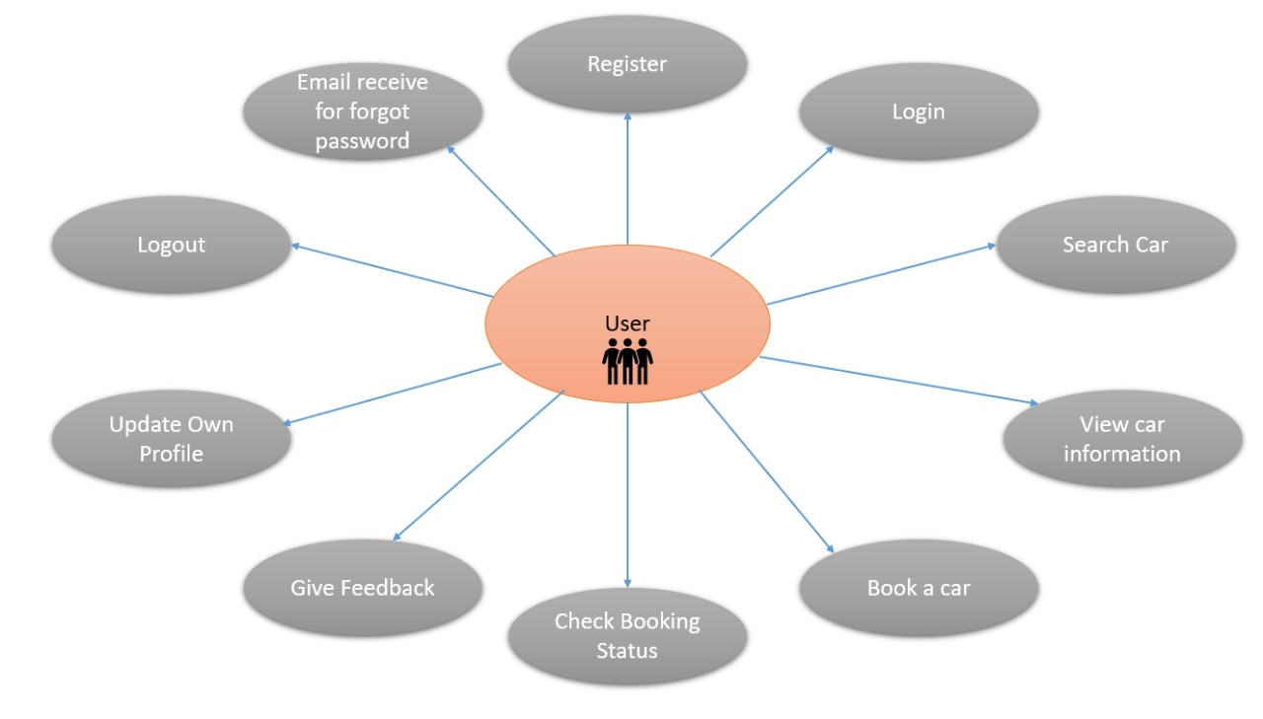

**Admin Diagram:**

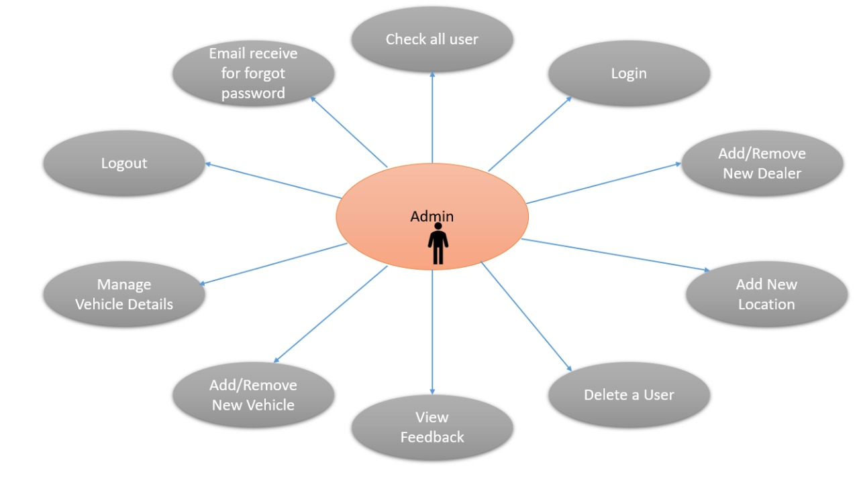

**Dealer Diagram:**

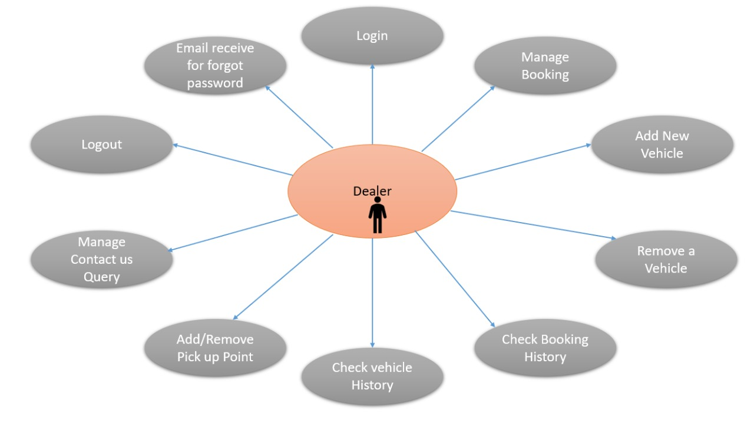

**Class Diagram:**

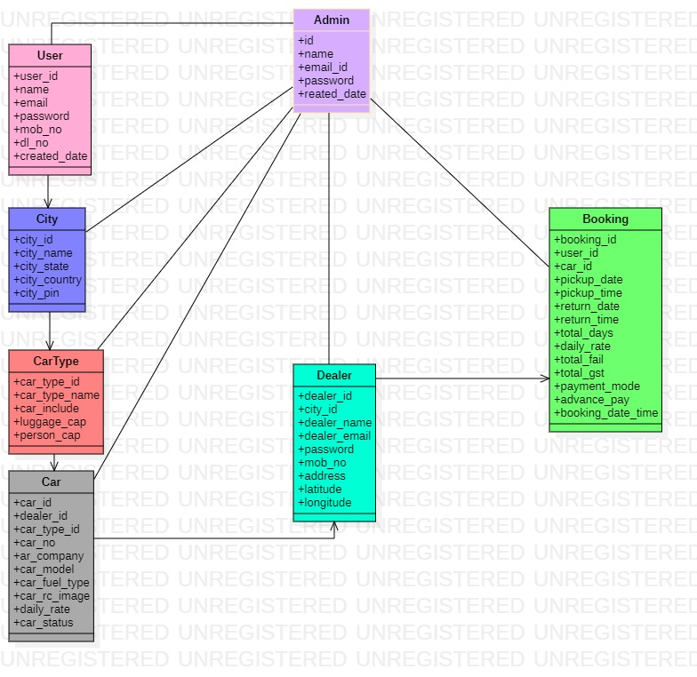

**Data Flow Diagram:**

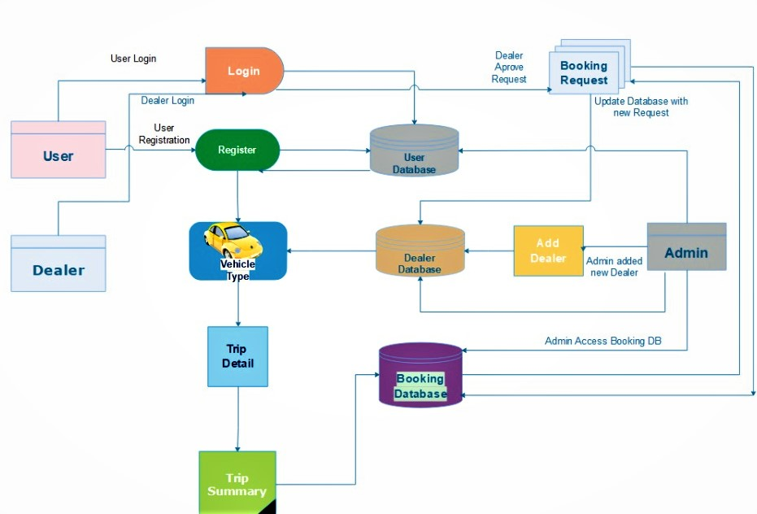

**Activity Sequence:**

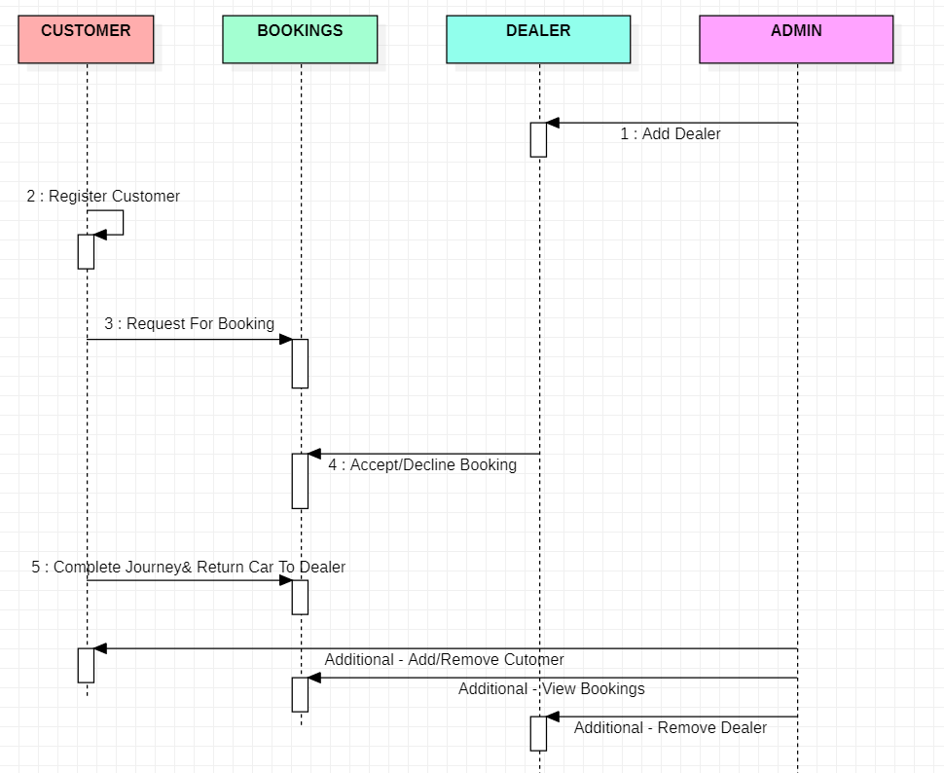

**ER Diagram:**

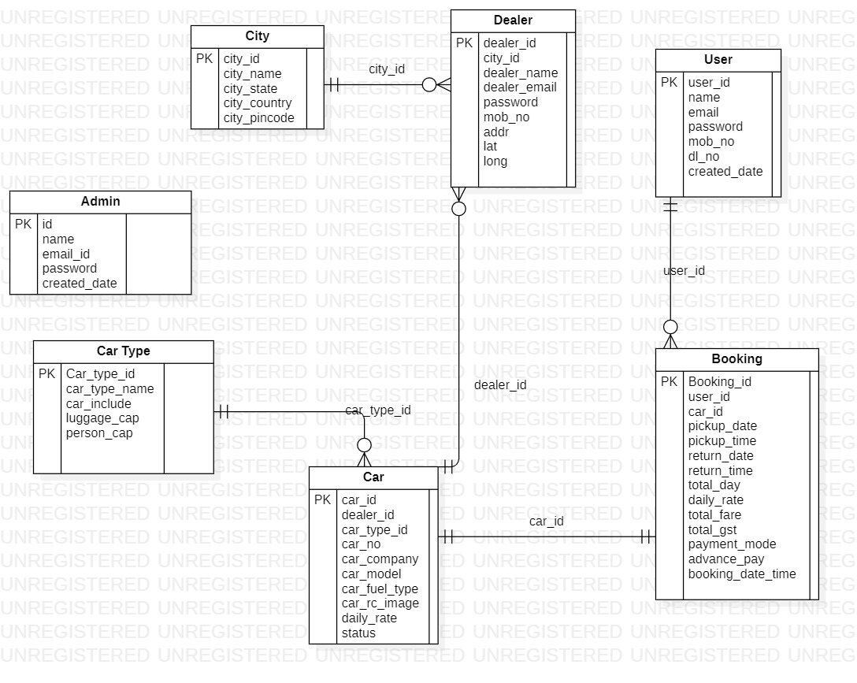

**Zero Level DFD**

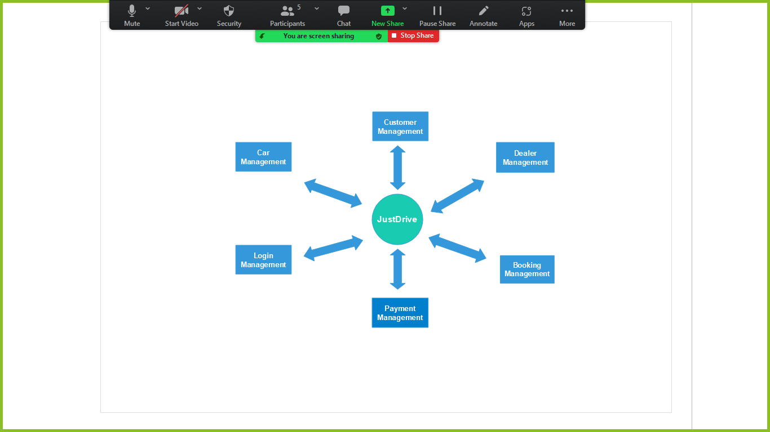

**First Level DFD**

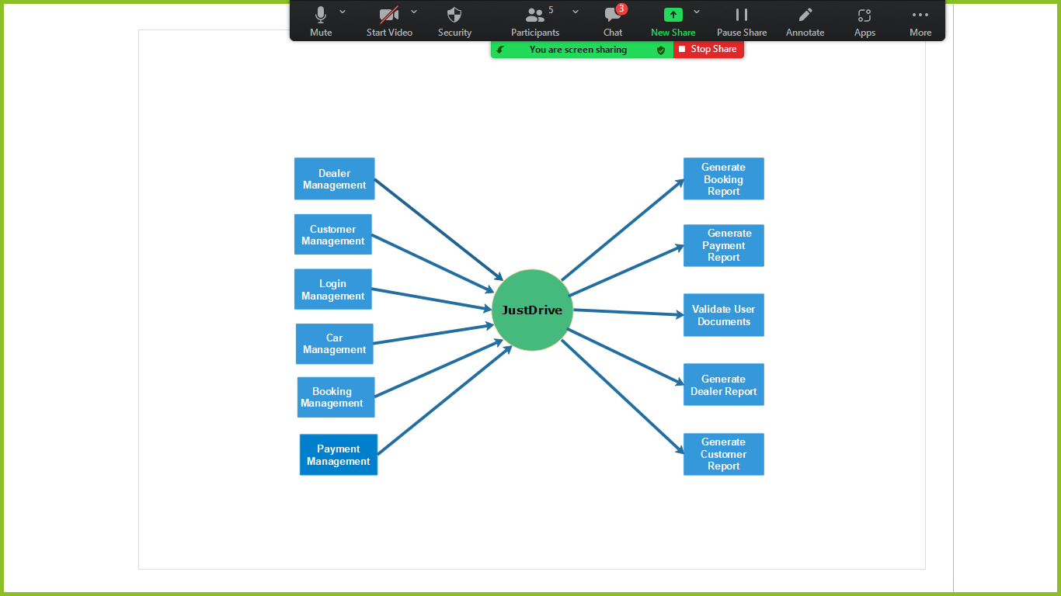

**IMPLENTATION**

**1 Customer:**

1. Register With just Drive

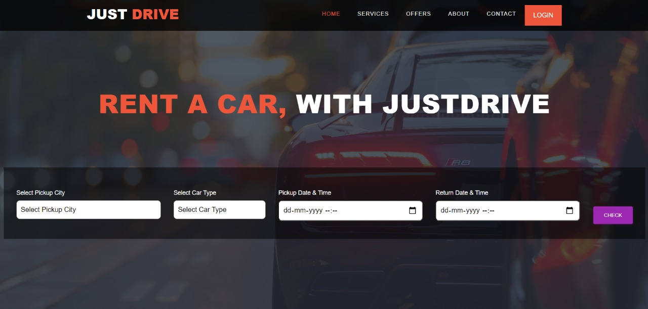

1. Select Your Pickup city with your nearest location.



1. Select your car Type like SUV, SEDAN, 7SEATER, HATCHBACK and many more
2. Select Pickup Date & Time also Return Date & Time;
3. Book a car with Advance online Payment (many Cars are available like Brezza, Creta, Desire, Baleno, Fortuner, Scorpio, Alto, maruti800 etc.)
4. Dealer will Approve your booking
5. Pick A car and enjoy your ride

**2 Dealer:**

1. Login with Just Drive
2. Dealer can view all available cars
3. Dealer can update the hourly rate of the cars
4. Dealer can add new car in list
5. Dealer can approve or cancel incoming Booking request for car by verifying customer details
6. View list of all Bookings

**3. Admin**

1. Login admin with valid details
2. Admin can add new city
3. Admin can add new dealer
4. Admin can see all Cars
5. Admin can see list of all dealers
6. Admin can see all the bookings
7. Admin can see list of all customers

**Technology Used:**

BACK END

* Spring Boot Hibernate.
* MYSQL for storage of data.

FRONT END

* React
* CSS
* REDUX

Platform:

* Web Development: J2EE Spring Boot, React, MySQL
* **J2EE Spring Boot**

Spring Boot has been built for Rapid Application Development. The goal of Spring Boot is to provide a way to create Java applications quickly and simply, through an embedded server. By default, it used an embedded version of Tomcat and hence eliminating the need of Java EE containers. It is a framework to ease the bootstrapping and development of new Spring Applications. Bootstrapping with defaults included in the configuration/ jar-dependencies. Easy to create standalone applications with embedded Tomcat/Jetty/Undertow. It provides defaults for code and annotation configuration to quick start new spring projects within no time. Plenty of Spring Boot Starter to quickly get up and running. No code generation and no requirement for XML configuration. It reduces lots of development time and increases productivity.

* **React**

React is a JavaScript library for building user interfaces. It has transformed the way we think about front-end development. React.js has clasped the engagement of the open-source community. And its demand is irreversible in the coming future. It is here to stay.

Improved performance: React uses Virtual DOM, thereby creating web applications faster. Virtual DOM compares the components’ previous states and updates only the items in the Real DOM that were changed, instead of updating all of the components again, as conventional web applications do.

* **MySQL**

MySQL is an open-source relational database management system (RDBMS).A list of commonly used MySQL queries to create database, use database, create table, insert record, update record, delete record, select record, truncate table and drop table etc. MySQL is a relational database management system based on SQL – Structured Query Language.

The application is used for a wide range of purposes, including data warehousing, e-commerce, and logging applications. The most common use for MySQL, however, is for the purpose of a web database. It can be used to store anything from a single record of information to an entire inventory of available products for an online store. In association

with a scripting language such as PHP or Perl (both offered on our hosting accounts) it is possible to create websites which will interact in realtime with a MySQL database to rapidly display categorized and searchable information to a website user.

**Future Scope:**

* For Better Security we can use JWT authentication.
* Payment getaways for online offline payment

**References Used:**

* <https://docs.oracle.com/en/java/javase/11/docs/api/>
* https://docs.spring.io/spring-data/jpa/docs/current/reference/html/#reference